SMART BIKE MOBILITY ANALYTICS DASHBOARD
1.Project Overview
This project focuses on analyzing smart bike mobility operations and station performance using Power BI and Excel. The dashboard provides insights into bike availability, station utilization, operational efficiency, and city-wise bike distribution across multiple bike stations.
The analysis transforms raw mobility data into interactive business intelligence that helps monitor transportation efficiency and bike-sharing infrastructure performance.
- What is the Project About?
- The project helps analyze:
- Bike availability trends
- Open vs Closed station performance
- Bike stand capacity utilization
- Quarterly bike availability growth
- City-wise bike distribution
- Operational efficiency monitoring
- Smart mobility infrastructure analysis
The dashboard enables transportation authorities and mobility service providers to track bike-sharing performance and optimize station operations effectively.
- Problem Statement
Smart bike-sharing systems generate large volumes of operational data daily, but raw datasets do not provide meaningful business insights directly.
- This project solves challenges such as:
- Difficulty monitoring bike availability
- Limited visibility into station performance
- Challenges in identifying low-performing stations
- Lack of city-wise mobility insights
- Difficulty tracking operational efficiency trends
- Inefficient monitoring of bike stand utilization
By using Power BI, the project converts complex transportation data into interactive analytics for operational decision-making.
- Why is this Analysis Important?
- This analysis helps:
- Monitor smart mobility operations
- Improve bike-sharing efficiency
- Optimize station capacity utilization
- Track operational performance
- Support smart city transportation planning
The dashboard supports data-driven decision-making for sustainable urban mobility systems.

2. Data Sources
- Dataset Source: Smart Bike Mobility Dataset
- Timeline: 2022 – 2025
- Data Size: 2K+ stations and operational records
- Data Type: Transportation & Mobility Analytics

3. Objectives
- Bike Availability Trend Analysis (Line Chart)
Analyze daily and monthly bike availability trends to identify operational fluctuations, peak usage periods, and overall bike-sharing performance across reporting timelines.
- Station Status Distribution Analysis (Donut Chart)
Compare the percentage share of open and closed stations to evaluate operational efficiency and station availability across the bike mobility network.
- Quarterly Bike Availability Analysis (Area Chart)
Monitor quarterly changes in bike availability and identify seasonal or operational growth patterns in bike-sharing activities.
- Bike Stand Capacity Analysis (Horizontal Bar Chart)
Evaluate station-wise stand capacity and identify high-capacity stations supporting larger rider demand and operational scalability.
- City-wise Bike Availability Analysis (Clustered Column Chart)
Compare bike availability across different cities to identify top-performing operational regions and mobility distribution patterns.
- Bike Availability Efficiency Monitoring (Gauge Chart)
Measure overall bike availability percentage to evaluate operational utilization efficiency and identify opportunities for performance optimization.

4. Tools & Technologies
- Power BI
Power BI was used as the primary tool for the complete project development process including data cleaning, transformation, modeling, analysis, and dashboard creation.
- Power BI Features Used
- Power Query Editor
Used for:
- Data cleaning
- Removing duplicate records
- Handling missing values
- Data transformation
- Column formatting
- Data type conversion
- Splitting date and time columns
- Creating calculated columns

5. Data Pre-Processing
- Tasks Performed
- Data Import
- Imported mobility datasets into Power BI
- Verified schema consistency
- Validated station records
- Data Cleaning
- Removed duplicate records
- Standardized station names
- Corrected missing values
- Validated operational status fields
- Data Type Conversion
- Converted date fields into Date format
- Converted availability columns into numeric format
- Validated percentage calculations
- Data Validation
- Verified station counts
- Validated bike availability metrics
- Ensured operational consistency

6. Data Modeling & DAX (Power BI)
- Data Modeling
The dashboard follows a Star Schema Architecture for better performance and simplified reporting.
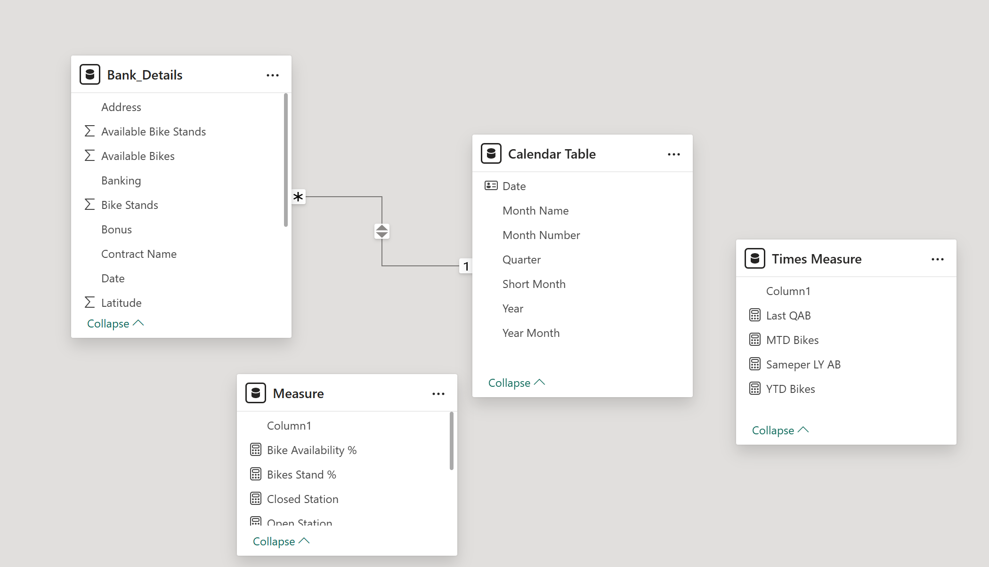
- Model Components:
- Fact Table (Bike Operations Data)
- Station Dimension Table
- City Dimension Table
- Date Calendar Table
- This model supports:
- Time intelligence analysis
- Station-wise comparison
- Availability trend analysis
- KPI monitoring
- Benefits of Data Modeling
- Faster dashboard performance
- Efficient filtering
- Better DAX optimization
- Improved scalability
- Simplified reporting structure

7. DAX Measures & Calculations
- KPI Measures Created
- Bike Availability %
- Total Available Bikes
- Total Available Stands
- Total Stations
- Open Stations
- Closed Stations
- Quarterly Bike Availability
- City-wise Bike Availability

8. Analysis & Visualizations (Power BI)
Dashboard Design
An interactive Power BI dashboard was developed to analyze smart bike mobility performance, operational efficiency, and station availability trends.
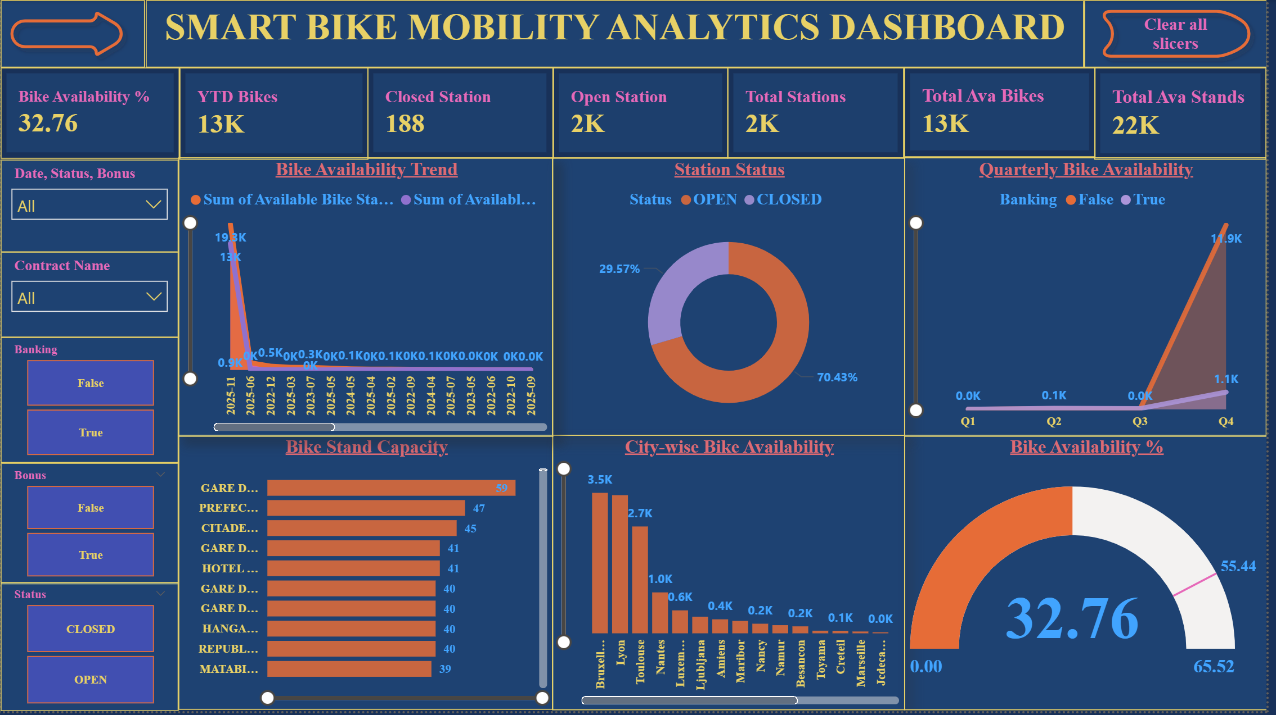
- The dashboard includes:
- KPI Cards
- Line Charts
- Donut Charts
- Area Charts
- Bar Charts
- Gauge Charts
- Interactive Slicers
- Dashboard Features
- KPI Summary Cards
The dashboard highlights major operational KPIs:
- Bike Availability %: 32.76%
- Total Available Bikes: 13K
- Total Available Stands: 22K
- Total Stations: 2K
- Open Stations: Nearly 70.43%
- Closed Stations: Nearly 29.57%

- Bike Availability Trend (Line Chart)
Tracks bike availability trends over time and identifies operational fluctuations across reporting periods.
- Key Insight:
Bike availability exceeded 19.3K during peak operational periods while maintaining stable availability across multiple reporting dates.

- Station Status Analysis (Donut Chart)
Compares operational station distribution between open and closed stations.
- Key Insight:
- Open Stations: 70.43%
- Closed Stations: 29.57%
This indicates strong operational coverage across the bike-sharing network.

- Quarterly Bike Availability (Area Chart)
Analyzes quarterly changes in bike availability.
- Key Insight:
Q4 recorded the highest bike availability with nearly 11.9K bikes, showing strong operational expansion during later quarters.

- Bike Stand Capacity Analysis (Bar Chart)
Identifies stations with the highest stand capacity.
- Key Insight:
Top stations maintained stand capacities between 39–59 units, supporting higher rider demand and operational scalability.

- City-wise Bike Availability (Column Chart)
Compares bike availability across cities.

- Key Insight:
- Brussels recorded the highest bike availability with nearly 3.5K bikes.
- Leuven and Toulouse followed with strong availability levels above 2.5K.

- Bike Availability Gauge
Measures operational bike utilization efficiency.
- Key Insight:
Current bike availability efficiency stands at 32.76%, indicating moderate operational utilization with opportunities for optimization.

9. Insights & Conclusions (SMART Analysis)
- Specific
- Operational Insights
- Open stations contributed over 70% of operational activity.
- Brussels maintained the highest bike availability across all cities.
- Q4 showed the strongest operational performance.
- Infrastructure Insights
- Total available stands exceeded 22K.
- Bike-sharing infrastructure supports large-scale urban mobility operations.
- Measurable
- Performance Metrics
- Bike Availability Efficiency: 32.76%
- Total Available Bikes: 13K
- Open Station Share: 70.43%
- Q4 Bike Availability: 11.9K
- City Performance
- Brussels achieved nearly 3.5K available bikes.
- Top stations maintained capacities above 50 stands.
- Achievable
- Operational Improvements
- Increase bike redistribution efficiency
- Reduce closed station percentage
- Improve utilization in low-performing stations
- Strategic Opportunities
- Expand infrastructure in high-demand cities
- Optimize stand capacity planning
- Improve operational maintenance scheduling
- Relevant
- Business Relevance
- The dashboard supports:
- Smart city transportation planning
- Urban mobility optimization
- Infrastructure performance monitoring
- Sustainable transportation initiatives
- Industry Relevance
- The project aligns with:
- Smart mobility systems
- Green transportation initiatives
- Urban digital transformation
- Sustainable city development
- Time-Bound
- Short-Term Monitoring
- Daily station availability tracking
- Quarterly operational performance analysis
- Long-Term Insights
- Multi-year mobility trend monitoring
- Infrastructure expansion planning
- Smart transportation growth analysis

10. Final Conclusion
This project demonstrates how smart mobility data can be transformed into meaningful operational intelligence using Power BI and advanced analytics techniques.
- The dashboard successfully provides:
- Bike availability monitoring
- Station performance analysis
- Capacity utilization tracking
- City-wise operational comparison
- Smart mobility KPI monitoring
- Key findings indicate:
- Open stations contributed more than 70% of operational activity.
- Brussels maintained the highest bike availability with nearly 3.5K bikes.
- Quarterly availability peaked at 11.9K bikes during Q4.
- Bike availability efficiency currently stands at 32.76%, highlighting opportunities for operational optimization.
Overall, the dashboard serves as a strategic business intelligence solution for improving smart bike-sharing infrastructure, operational efficiency, and sustainable urban transportation planning.

